**Fatima Jinnah Women University**

Department of Software Engineering

**LAB 4**

**Name:** Raifa Khalid

**Reg. no:** 2020-BSE-024

**Section:** A

**Semester:** Fourth

**Course:** Data Base (LAB)

**EXAMPLES:**

*Using less than condition:*

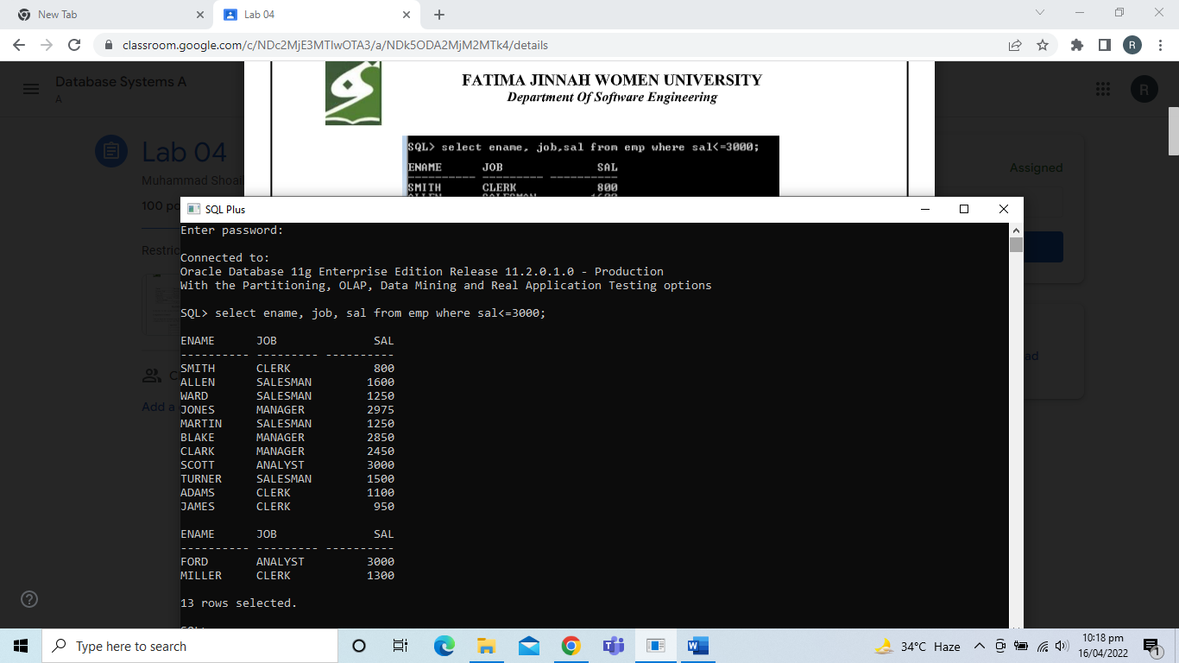

*Using BETWEEN condition:*

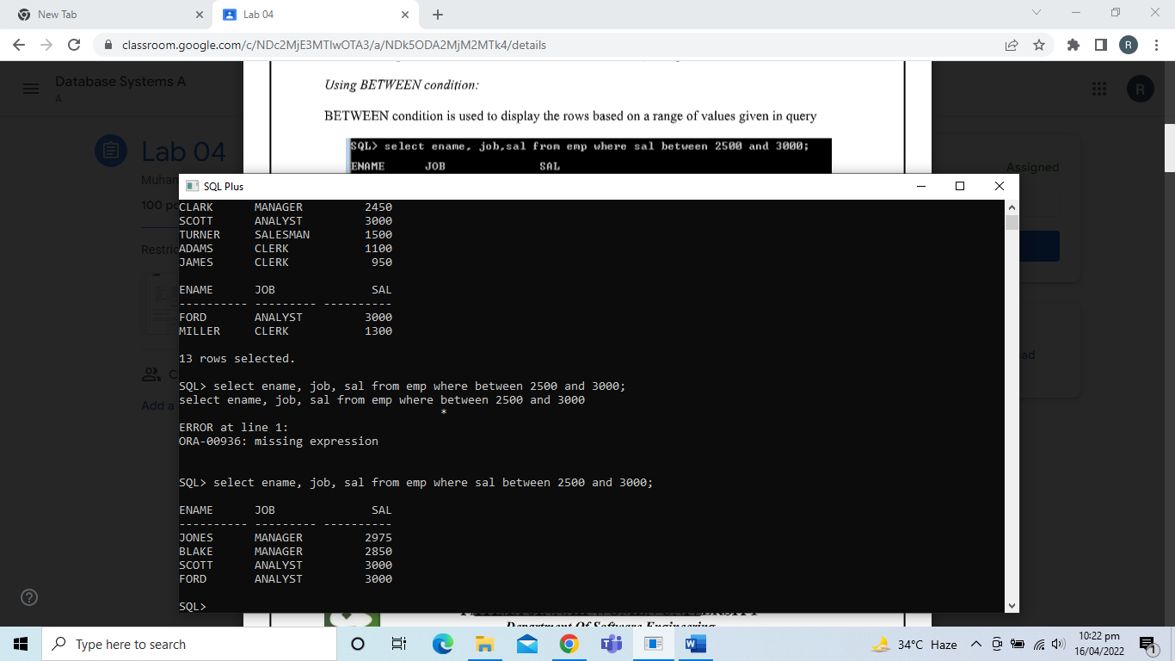

*Using IN condition:*

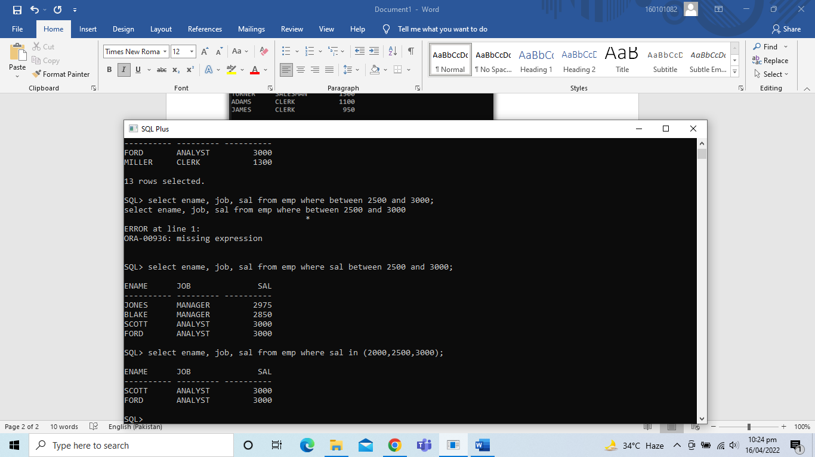

*Using LIKE condition:*

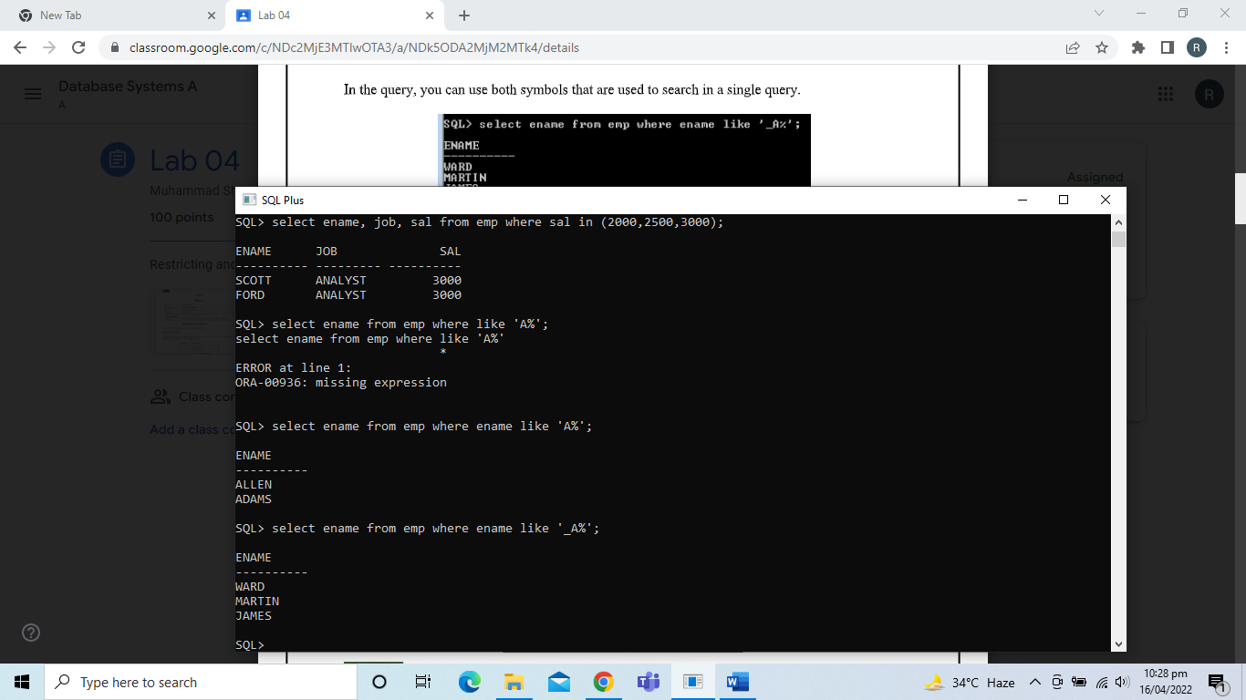

*Using the NULL condition:*

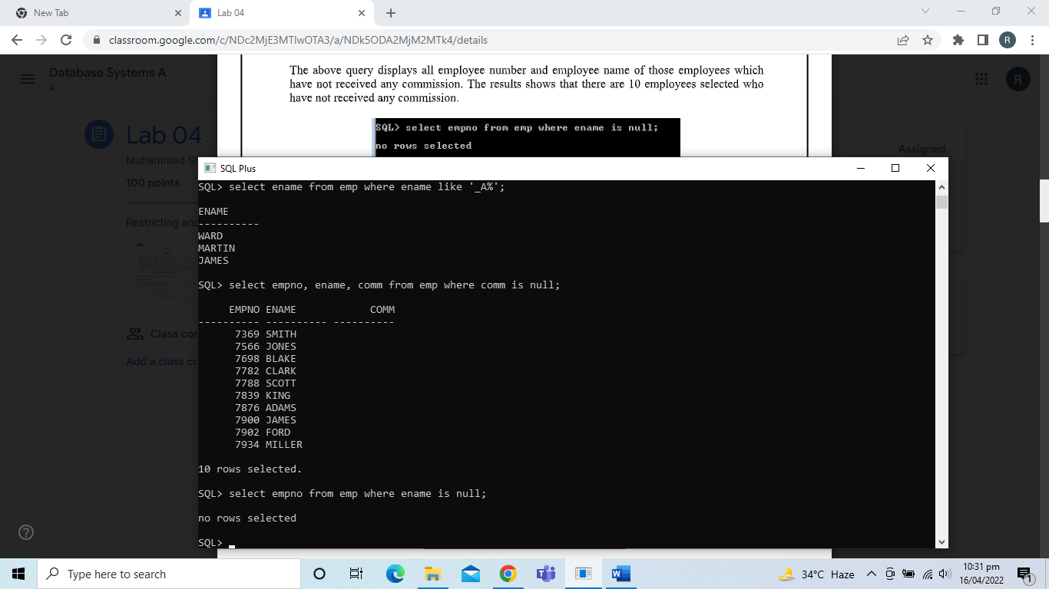

*Using the AND Operator:*

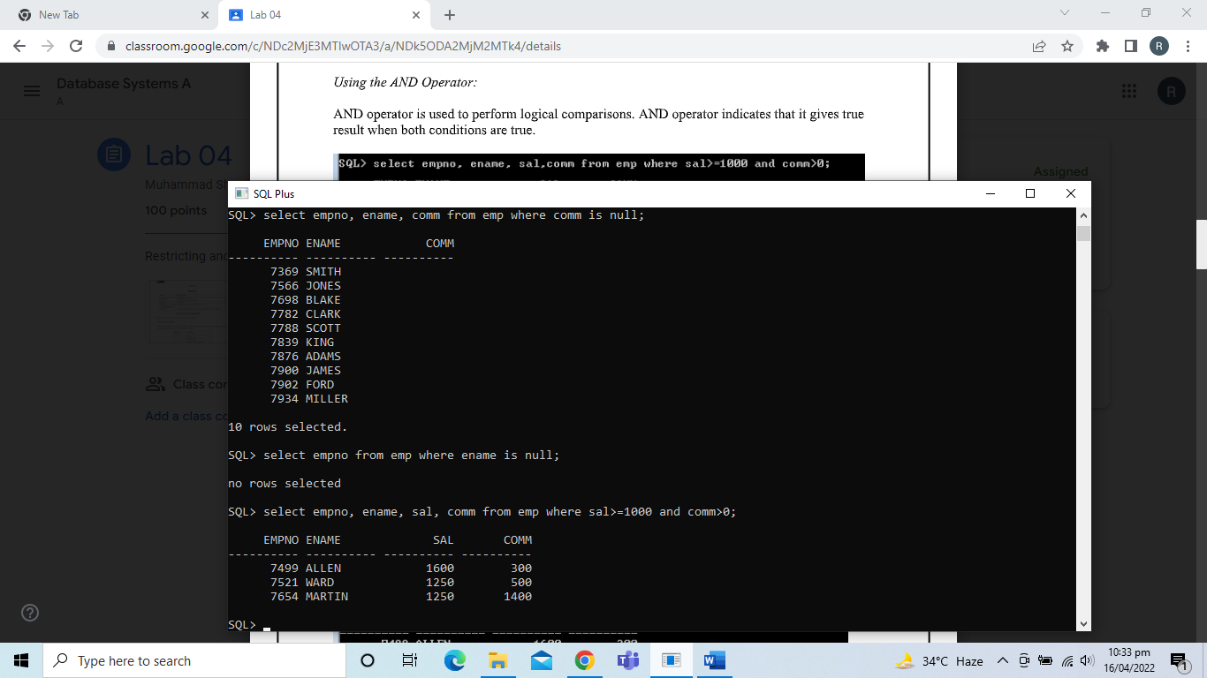

*Using the OR Operator:*

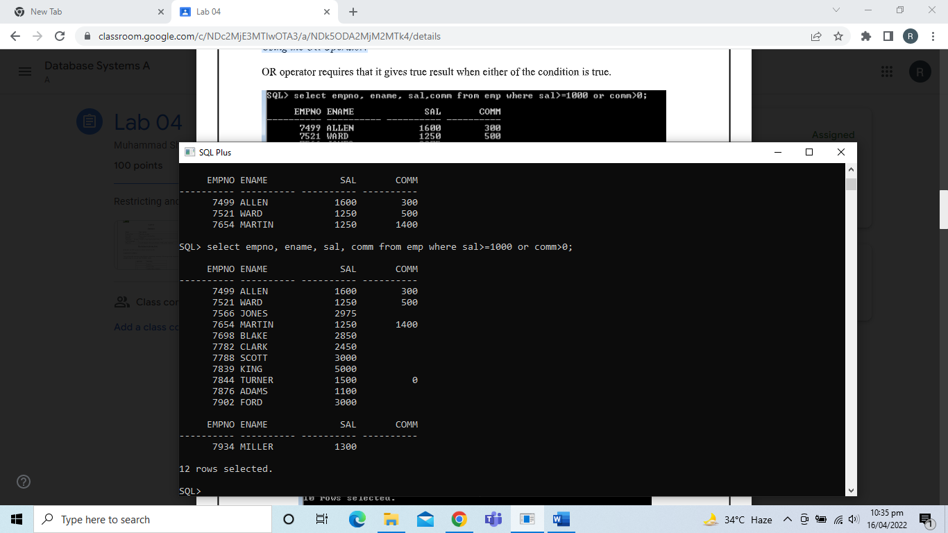

*Using the NOT Operator:*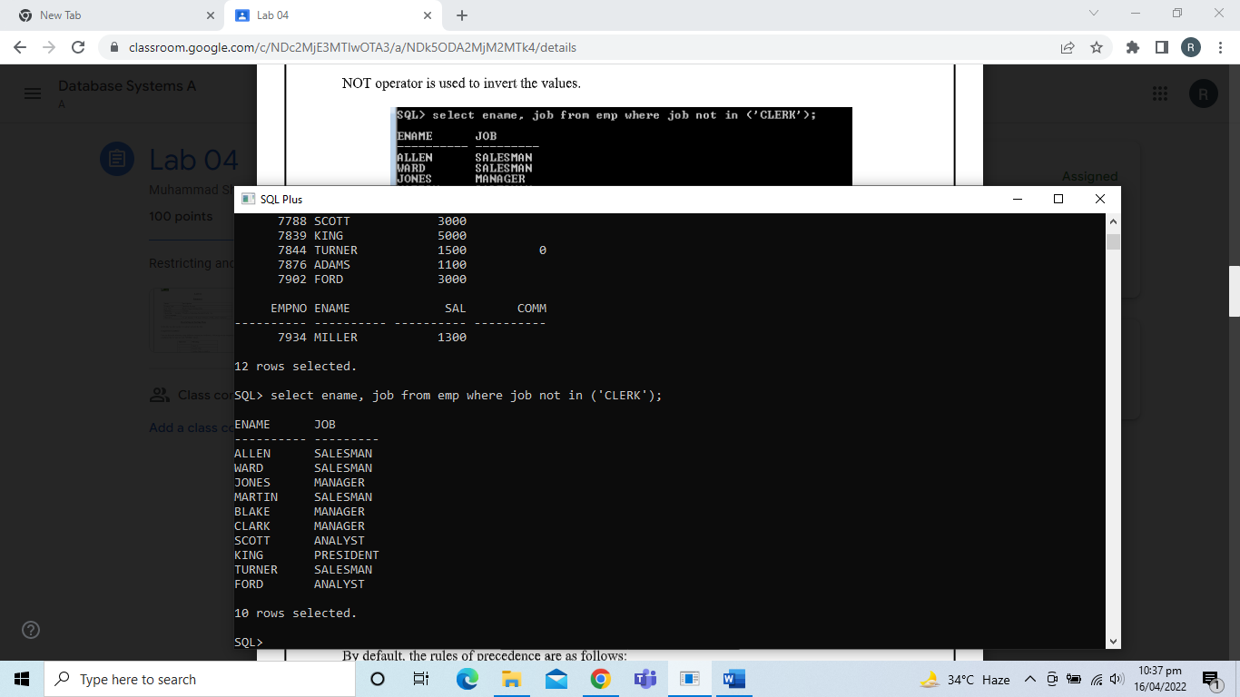

*Rules of Precedence:*

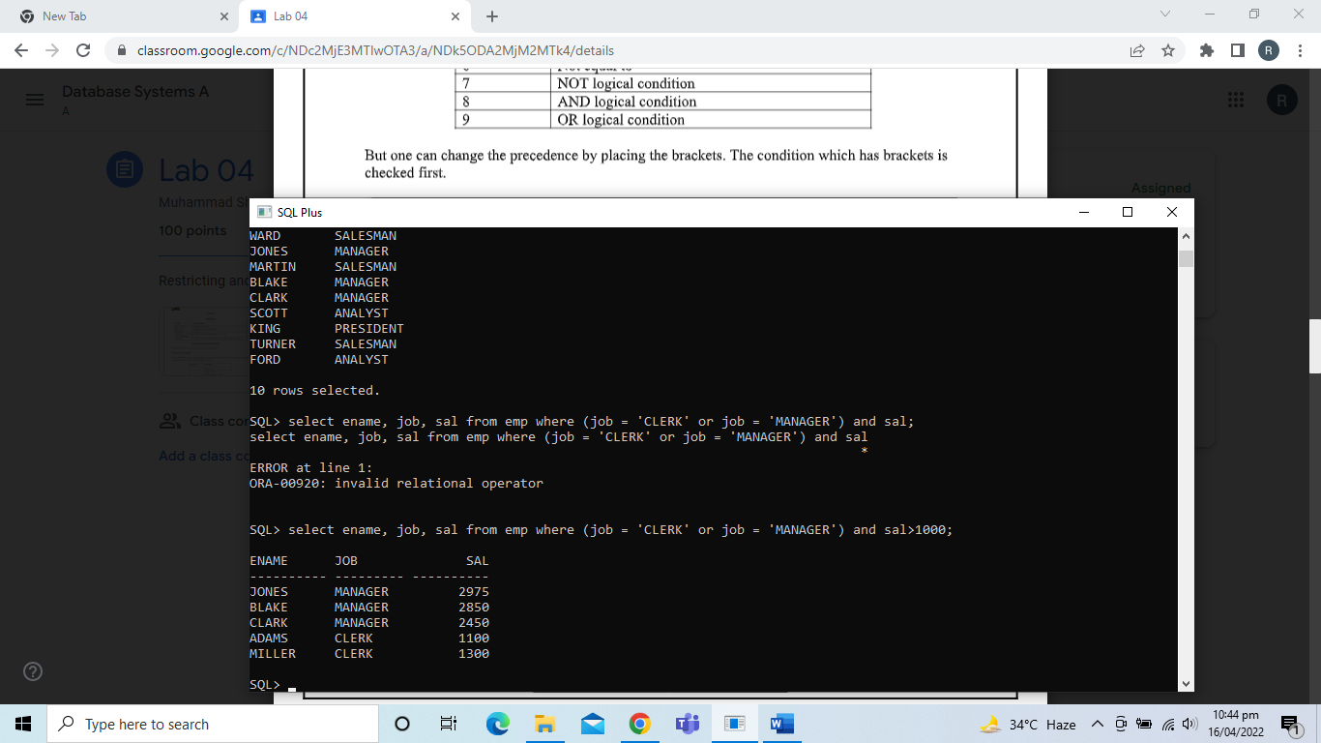

*ORDER BY Clause:*

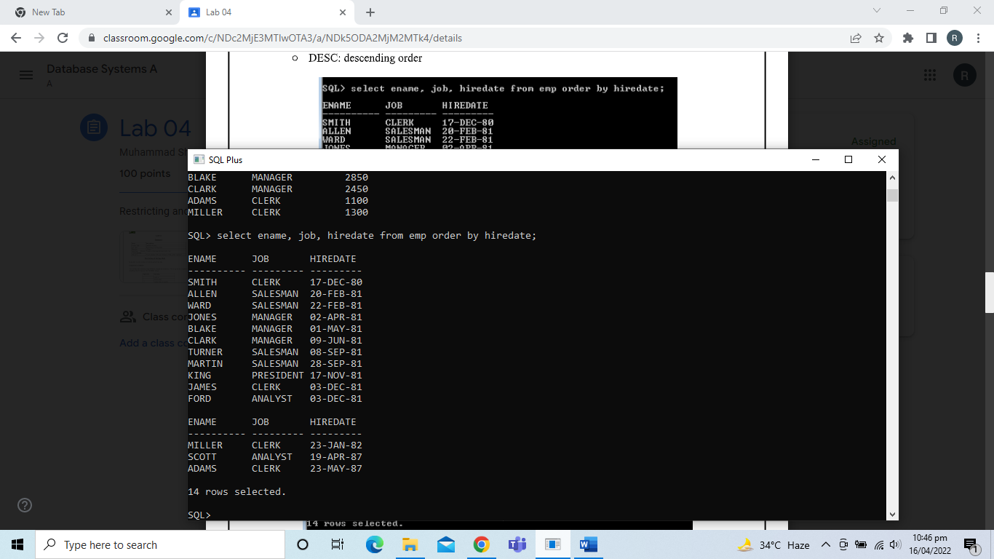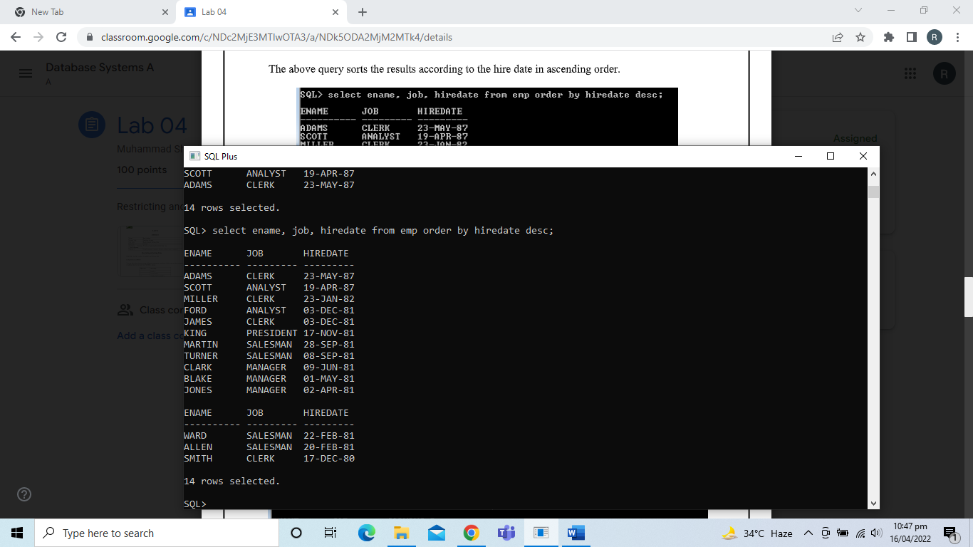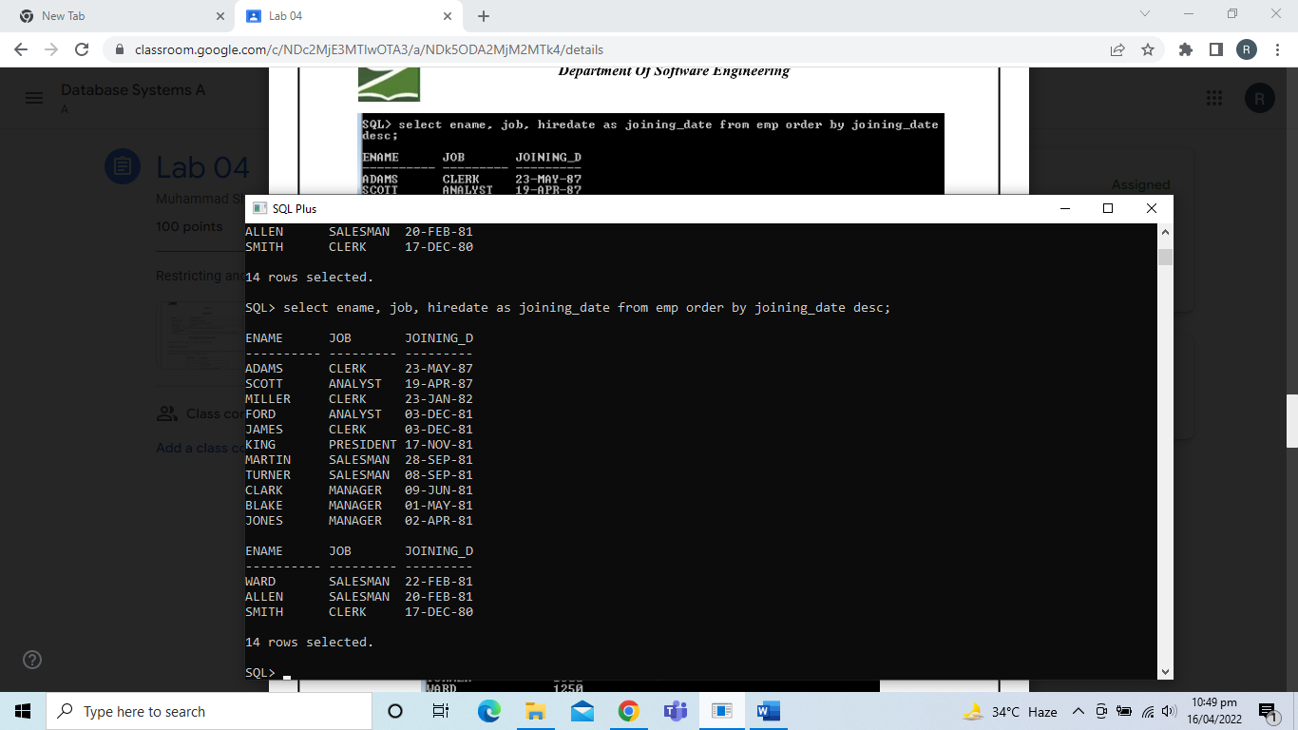

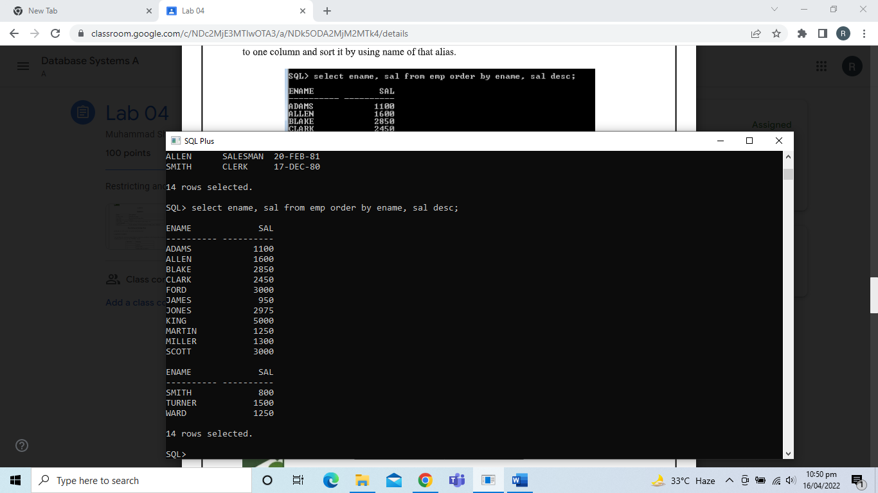

*Substitution Variables:*

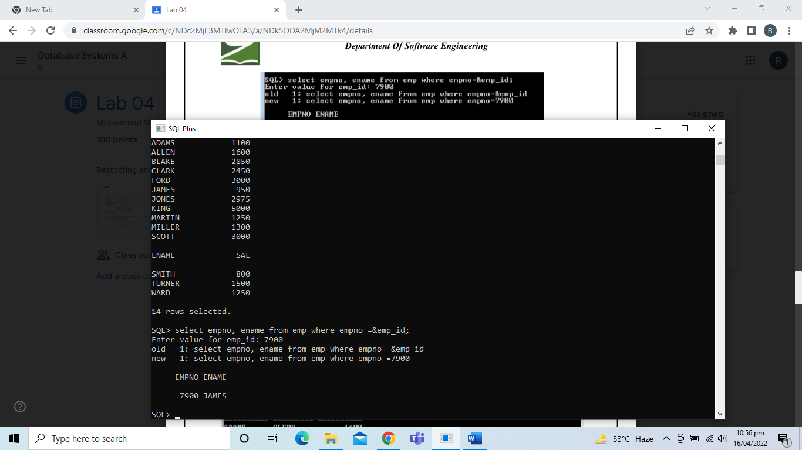

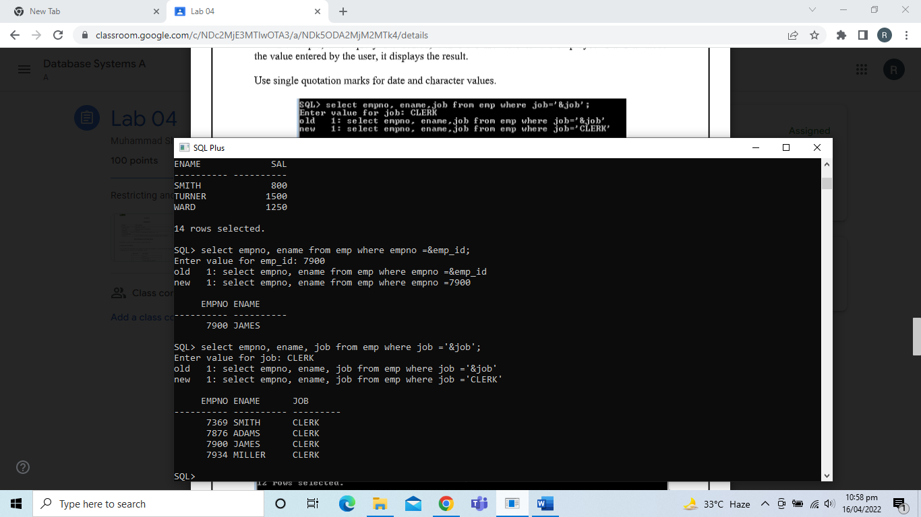

*Specifying Column Names, Expressions, and Text:*

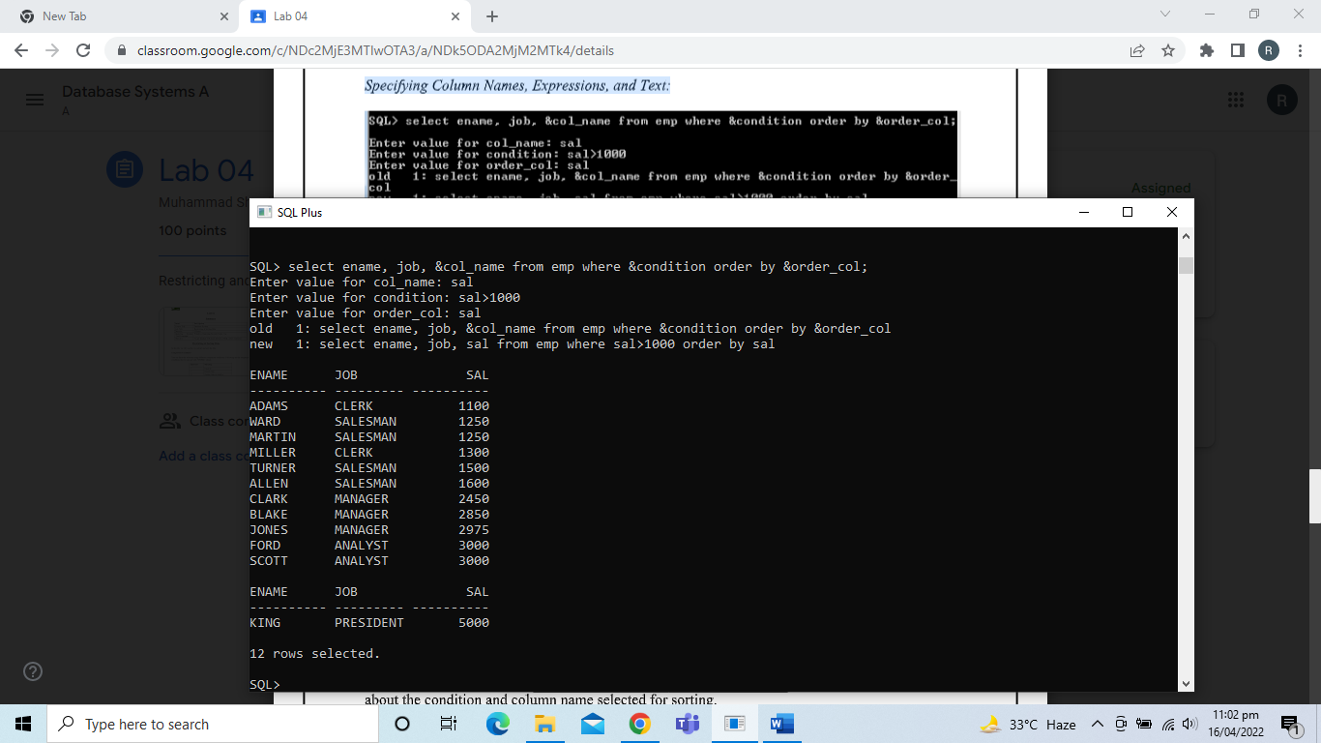

*Using the && Substitution Variable:*

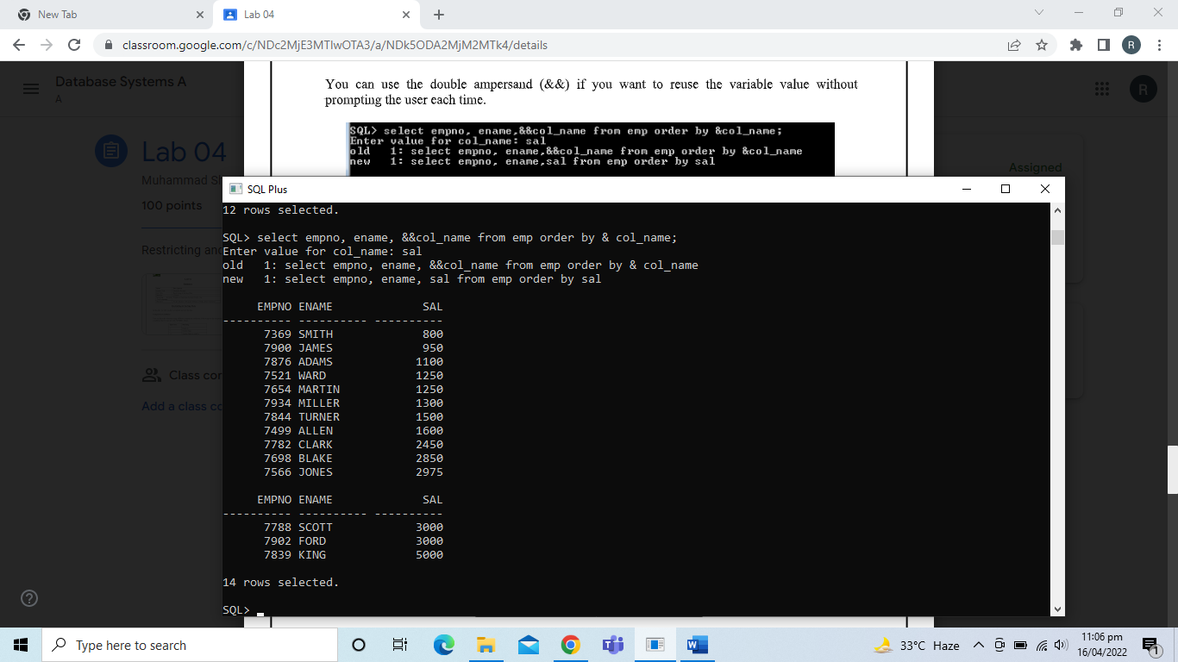

*Using the VERIFY Command:*

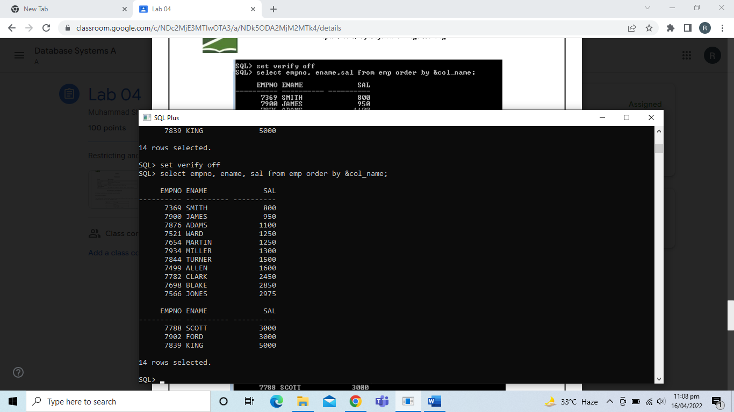

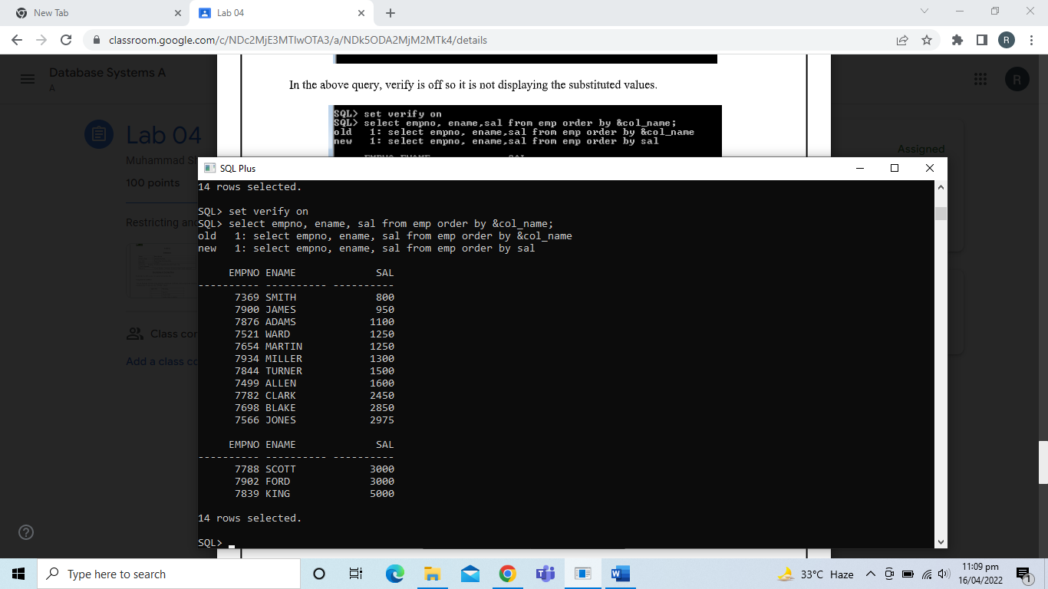

TASKS

1. **Create a query to display the employee name and salary of employees earning more than $1800.**

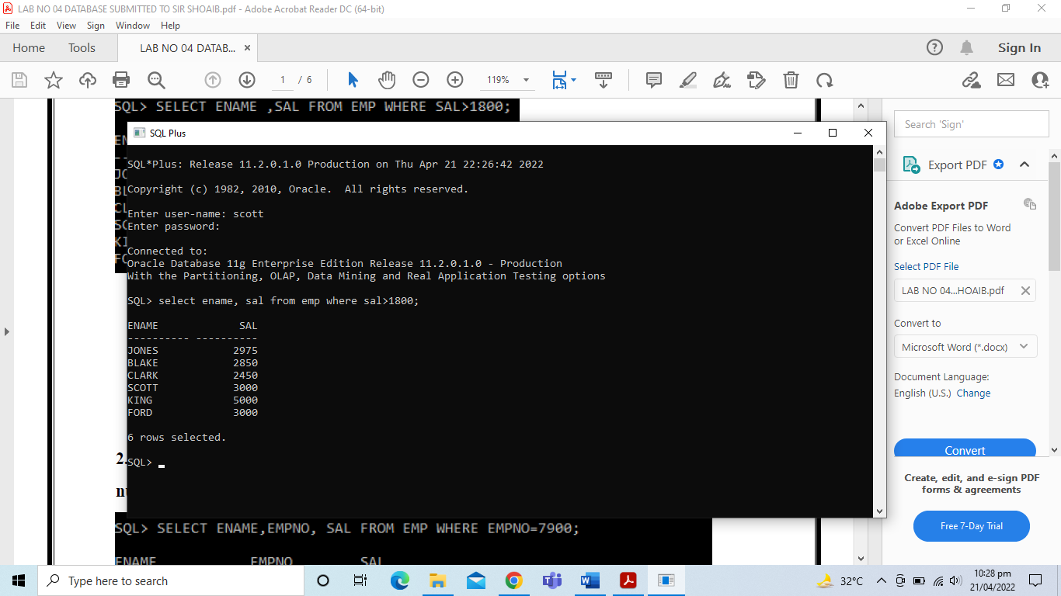

1. **Create a query to display the employee name and department number of for employee number 7900.**

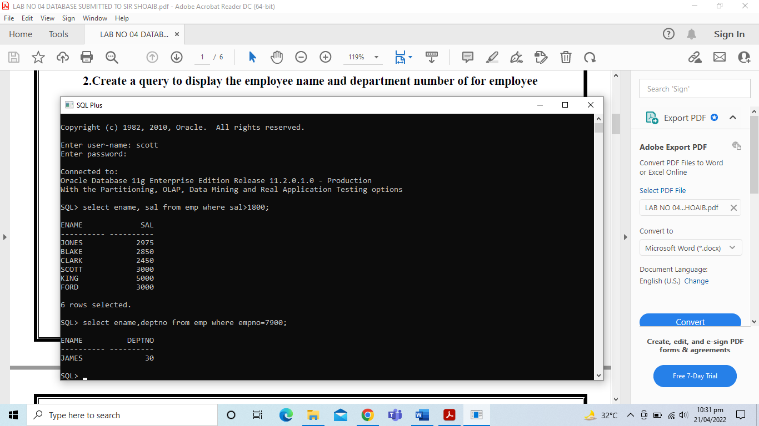

1. **Display the employee name and salary for all employees whose salary is not in the range of $500 and $1200.**

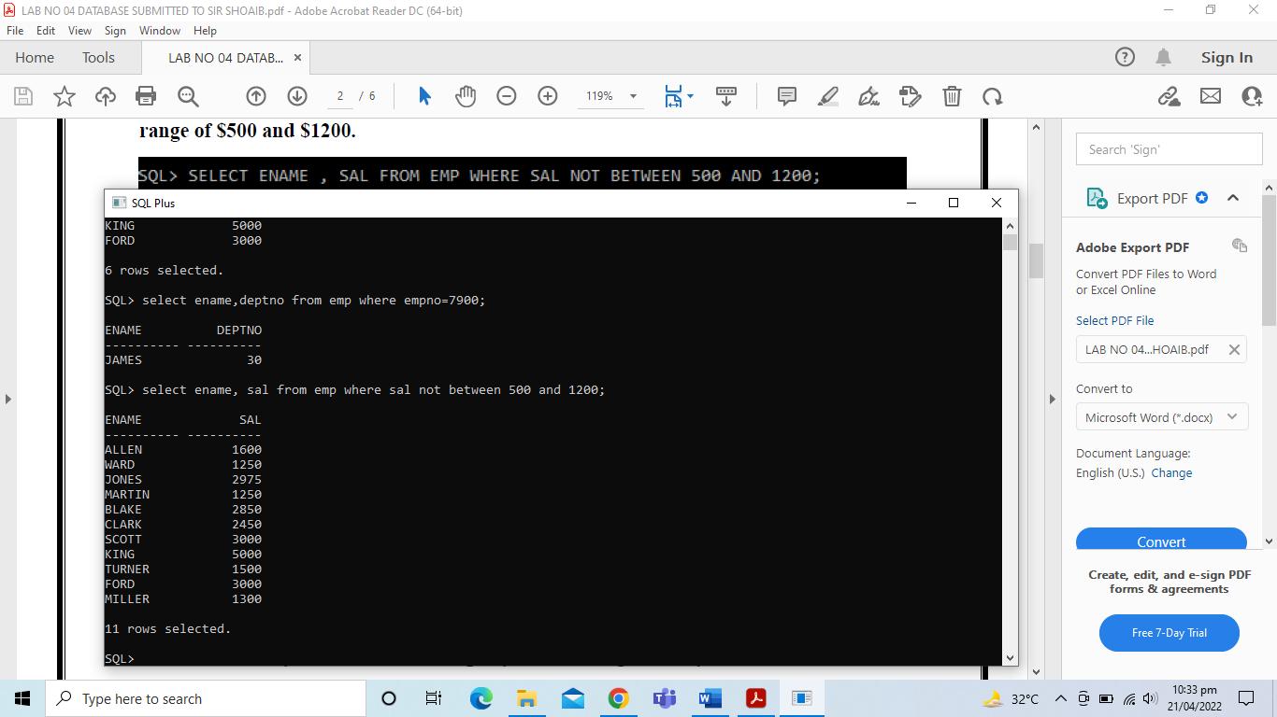

1. **Display the employee name, job, start date of employees hired between 20 February 1981 and May 1, 1982. Order the query in ascending order by start date.**

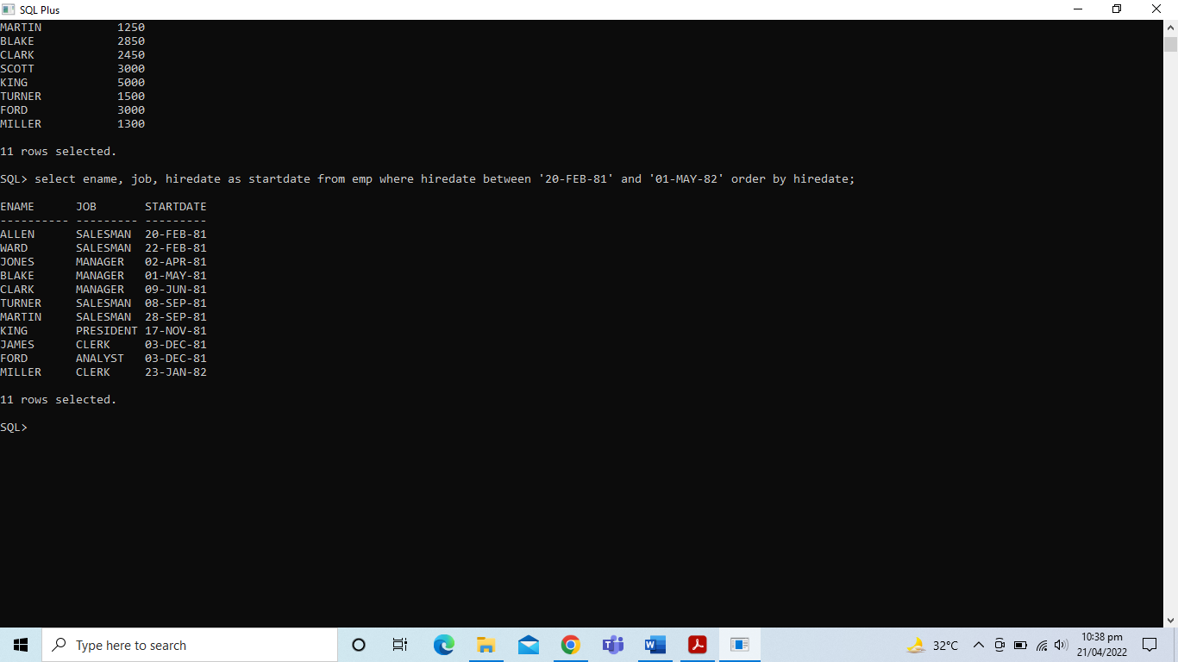

1. **Display the employee name and department number of all employees in department 20 and 30 in alphabetical order by name.**

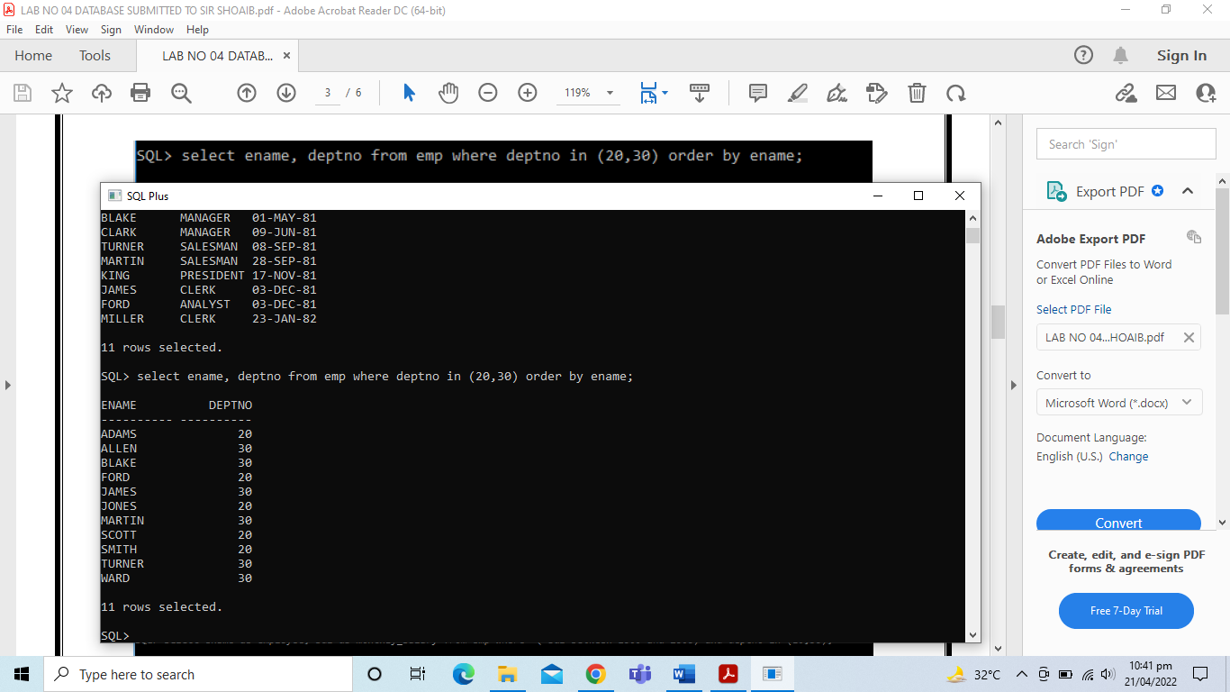

1. **List the last name and salary of employees who earn between $1000 and $2000 and are in department 10 or 30. Label the columns Employee and Monthly Salary, respectively.**

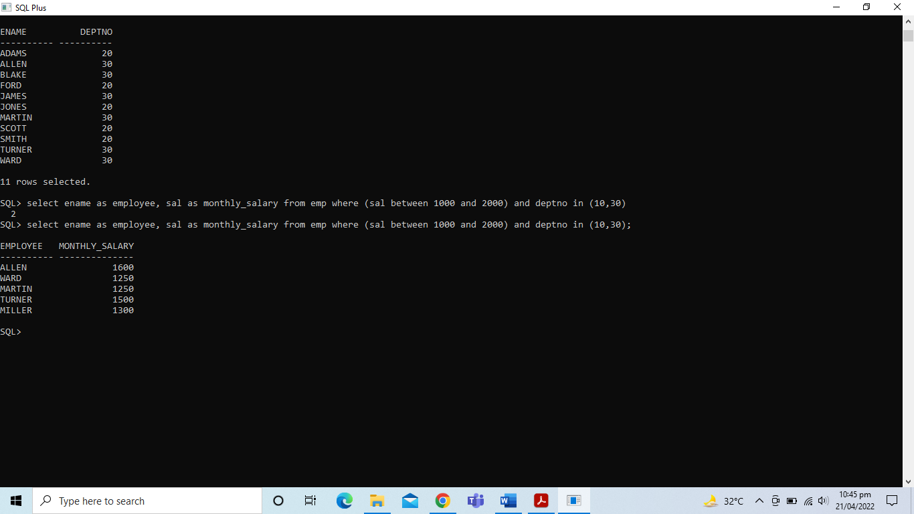

1. **Display the employee name and hire date of every employee who was hired in 1982.**

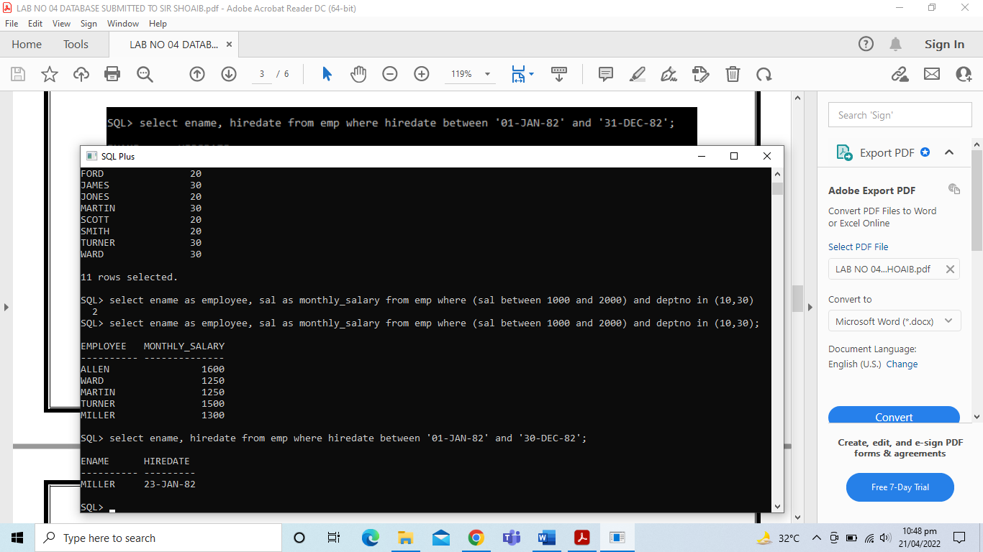

1. **Display the employee name and job title of all employees who do not have a manager.**

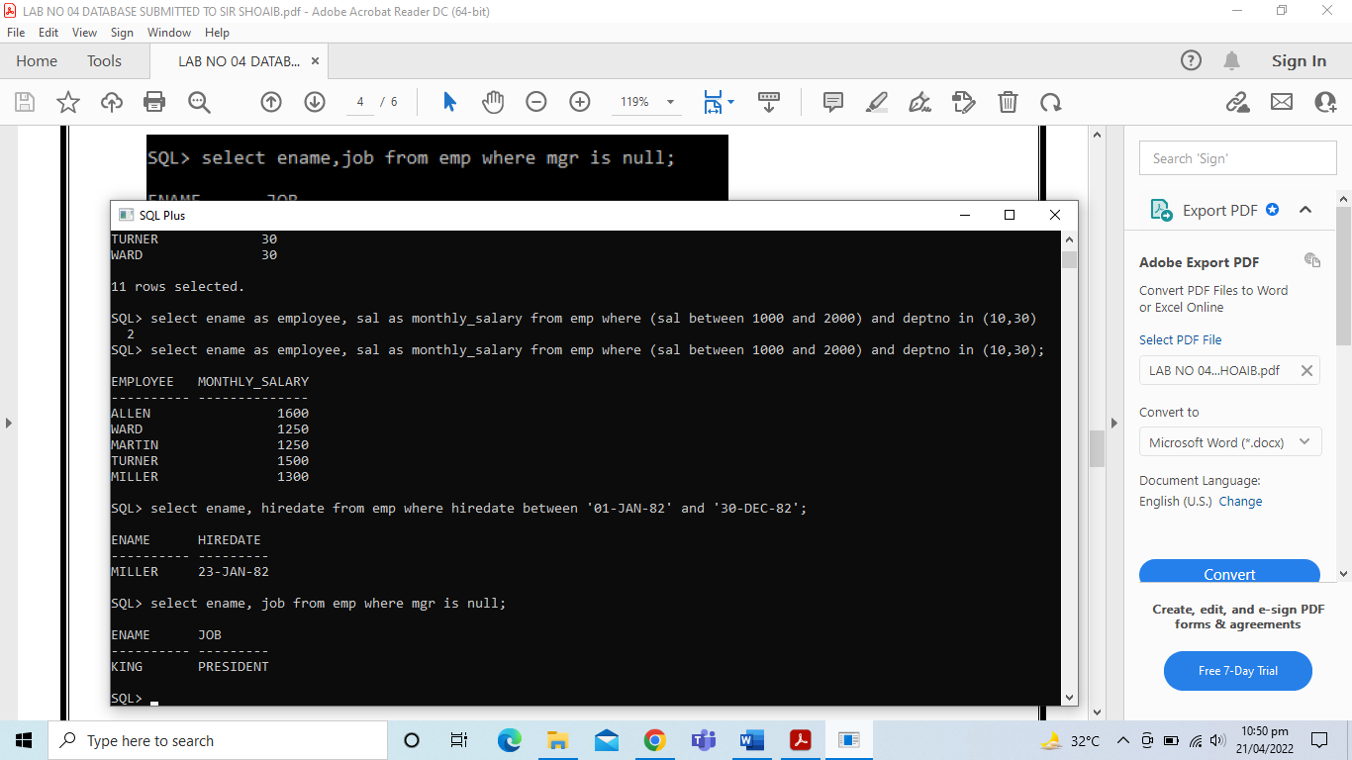

1. **Display the last name, salary, and commission for all employees who earn commissions. Sort data in descending order of salary and commissions.**

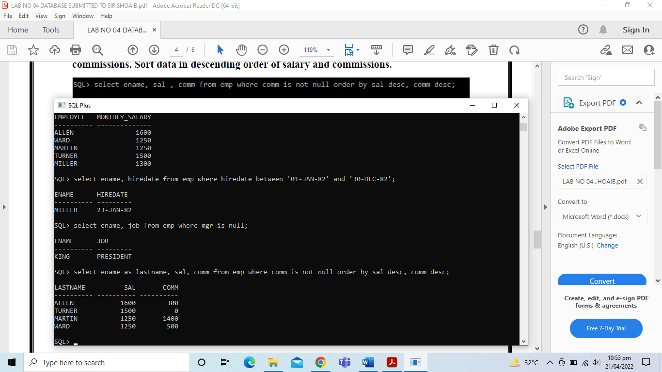

1. **Display all employee names of all employees where the third letter of the name is ‘a’.**

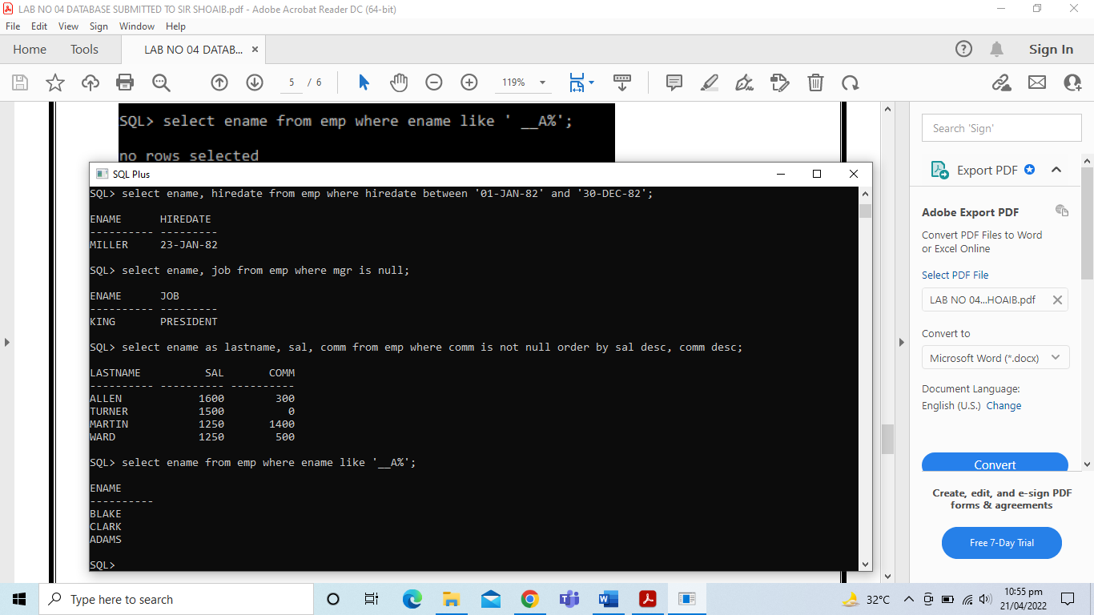

1. **Display the employee name of all employees who have an ‘a’ and ‘e’ in their name.**

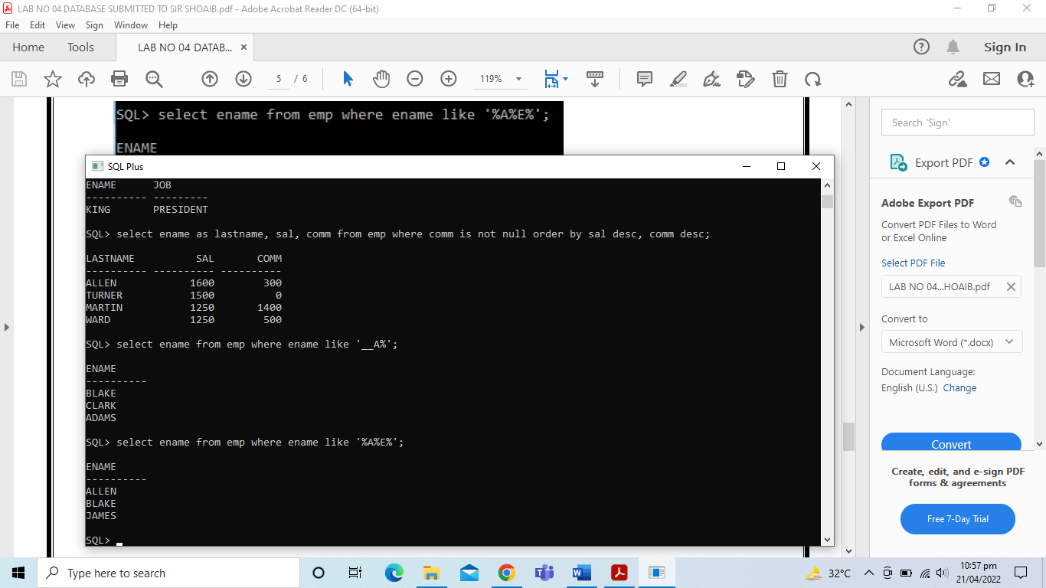

1. **Display the employee name, job and salary for employees whose job title is entered by the user and whose salary is not equal to $1000, $1200, $1800. Also sort the data according to the column name entered by the user.**

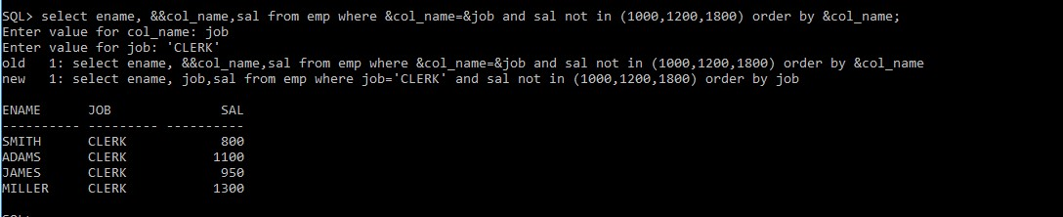

1. **Display the employee name, salary, and commissions for all employees whose commission amount is 20%.**

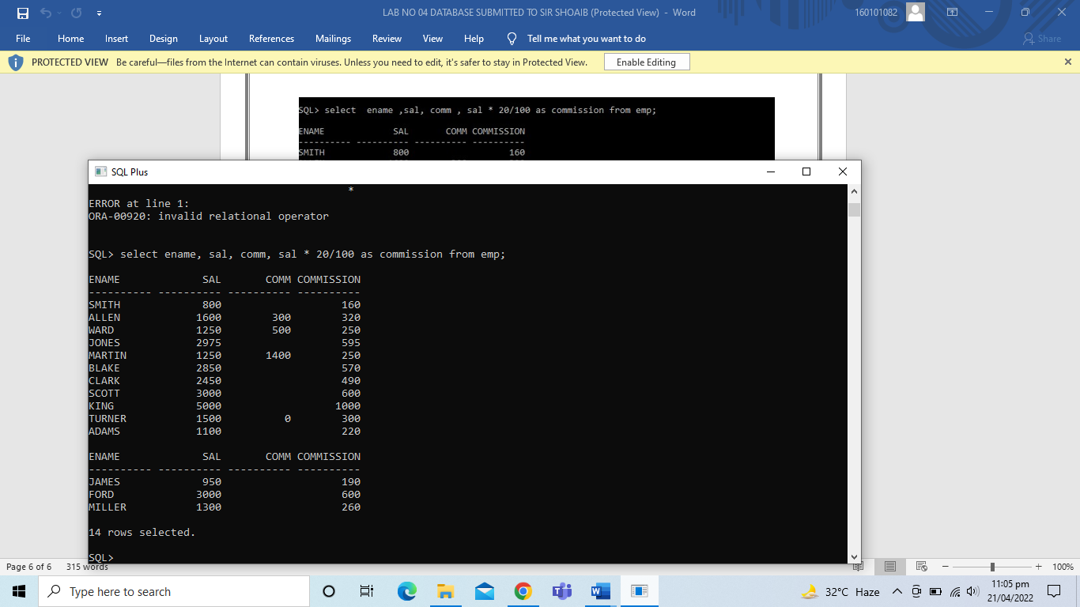

1. **Display the employee name, salary of all employees whose condition of salary is entered by user. Sort the data in descending order according to the salary.**

